Mount Waverley Water Main Renewal Project
24 June 2024

Start of works -Fleet Street
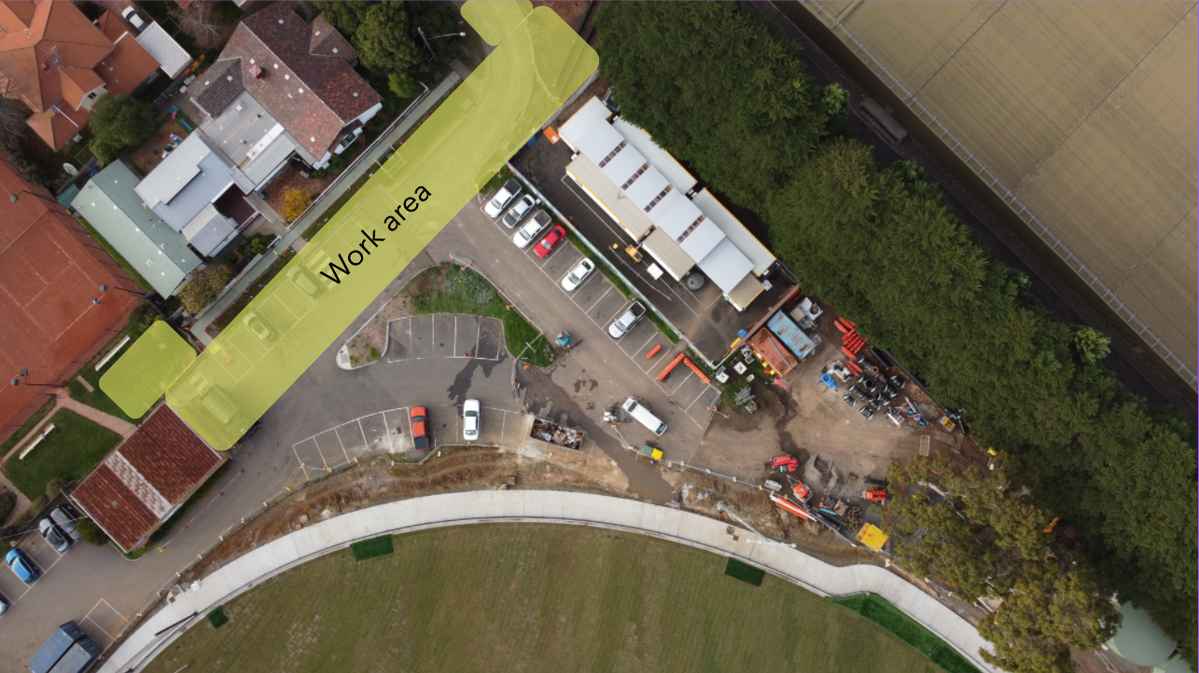
The second phase of Stage C – Fleet Street works (see figure 2) of the construction for the Mount Waverley Water Main Renewal Project will begin on Monday 1 July 2024. These works will require closure of Fleet Street from the bend and the oval car park. There will be no access into the Waverley Reserve oval. These works are expected to be completed by 20 September 2024.
Figure 1: Work area

What you can expect
Street parking: There will be limited on- street parking available in the neighbouring streets for both residents and businesses. Residents are encouraged to utilize their private parking garage during this period.
Noise and vibration: During construction there will be some noise and minor vibrations associated with the construction of the new water main. We will reduce these impacts as much as is safely possible.
Pedestrian access: Pedestrians access to the Learning Centre and Fleet Street will be maintained. Access to the tennis courts will be maintained through Charles Street. Exercise caution while walking past the work area.
Traffic flow: Increased construction vehicle movements on Fleet Street. Traffic management will be in place to help you safely move around the area. Please follow the signs and any directions from the traffic control staff.
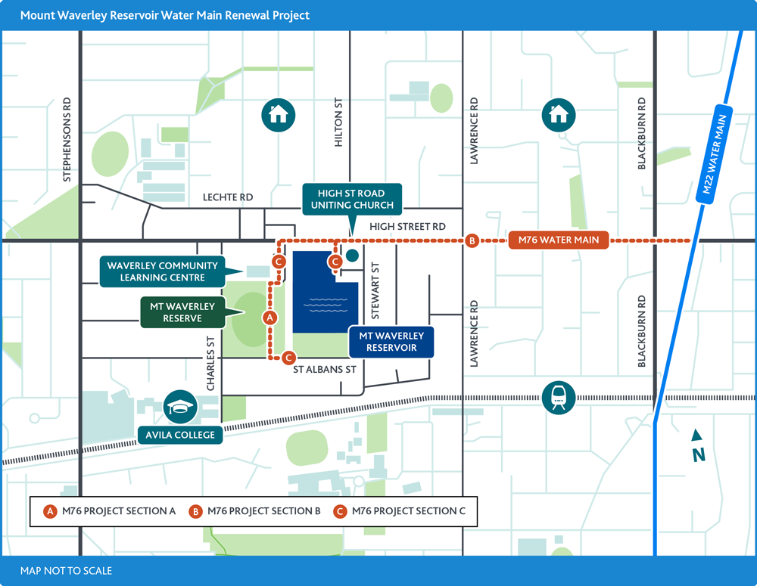

Figure 2: Project map/footprint

Working hours
Works are scheduled to take place between Monday to Friday, 7am-6pm and Saturdays 7 am-1pm. This is in line with EPA Guidelines.

Works are expected to take place until 20th September 2024.
Prior notification will be provided if works are to occur outside standard times and if there are any delays.

